DESIGN MATRICES FOR GLM
STANDARD DESIGN MATRICES
The design matrices that we used in the last StatQuest [5] are not the standard design matrices used for doing t-tests and ANOVA.
This is what we used in the last StatQuest [5]:
$$X={\left[\begin{aligned}1 \\ 1 \\ 1 \\ 1 \\ 0 \\ 0 \\ 0 \\ 0\end{aligned}\begin{aligned} \\ \\ \\ \\ \end{aligned}\begin{aligned}0 \\ 0 \\ 0 \\ 0 \\ 1 \\ 1 \\ 1 \\ 1\end{aligned}\right]}_{8×2}$$
$$y=column1×{mean}_{control}+column2×{mean}_{mutant}$$
$$y={mean}_{control}+{mean}_{mutant}$$
This is the standard design matrix for t-tests and ANOVA (which corresponds to a slightly different equation):
$$X={\left[\begin{aligned}1 \\ 1 \\ 1 \\ 1 \\ 1 \\ 1 \\ 1 \\ 1\end{aligned}\begin{aligned} \\ \\ \\ \\ \end{aligned}\begin{aligned}0 \\ 0 \\ 0 \\ 0 \\ 1 \\ 1 \\ 1 \\ 1\end{aligned}\right]}_{8×2}$$
$$y=column1×{mean}_{control}+column2×\left({mean}_{mutant}-{mean}_{control}\right)$$
$$y={mean}_{control}+{difference}_{{mean}_{mutant};{mean}_{control}}$$
Both will get the job done, but the second one is much more common in practice.
The residuals are the same for both equations (and design matrices); the equations have the same number of parameters ($p_{fit}=2$), therefore we will get the same value for $F$ and that will result in the same p-value.
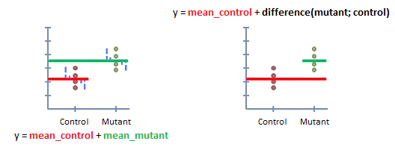

DESIGN MATRICES FOR LINEAR REGRESSION
A design matrix full of 1´s and 0´s is perfect for doing t-tests and ANOVAs - any time we have different categories of data - but we can use other numbers.
For example, here is a design matrix for linear regression (+ abstract equation) …
$$X={\left[\begin{aligned}1 \\ 1 \\ 1 \\ 1 \\ 1 \\ 1 \\ 1 \\ 1\end{aligned}\begin{aligned} \\ \\ \\ \\ \end{aligned}\begin{aligned}0,9 \\ 1,6 \\ 2,3 \\ 3,5 \\ 4,2 \\ 5,1 \\ 5,5 \\ 5,6\end{aligned}\right]}_{8×2}$$
$$y=column1×b+column2×a$$
$$y=intercept+slope$$
We´ve got a bunch of 1´s in the first column, and in the second column, we´ve got the x-axis position for each point.
Plugging each row into the equation gives us a bunch of points on the least-squares fit line.
Once we have all the points in the line … we can calculate the residuals … and that means we can calculate R-squared the a p-value.
This example shows that a design matrix isn´t always a bunch of 0´s and 1´s, but can be any set of numbers that we want to plug into an equation, one row at a time.
T-TEST IN REGRESSION
Now that we know we can put any number into the design matrix, let´s do something fancy … Let´s combine a t-test and a regression!!!
We´re back to the relationship between mouse weight and mouse size. However, now we have two types of mice …
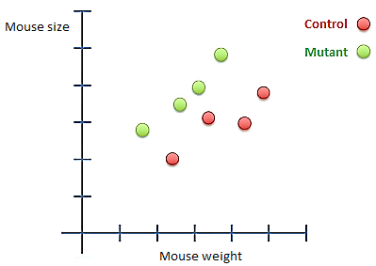
By eye, we can see that mutant mice tend to be larger, even if they weight the same. In other words, the mutant mice seem to follow the green trend, and the control mice seem to follow the red trend.
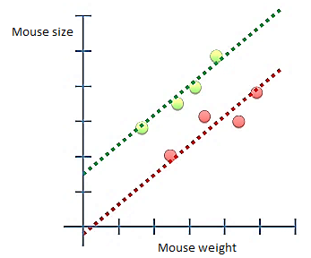
Can we use statistics to test if there is a significant difference between the two types of mice ?
If we just did a regression, we would get a nice looking line, but it wouldn´t tell us if the mutant mice were significantly larger than the normal mice.
On the other hand, a normal t-test would ignore the relationship between weight and size (and in this case the p-value is > 0,05).
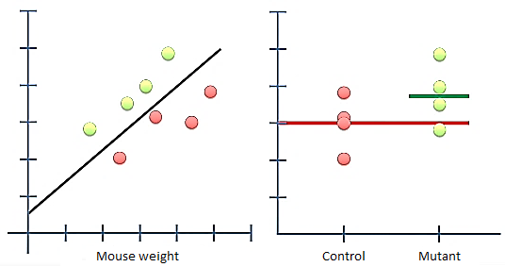
Since mouse type and the relationship between weight and size are both important, we need to combine them into a single test. In other words, instead of comparing the means (which is what a t-test would do), we want to compare trends !
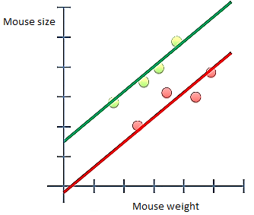
To do this, we need an equation that has a term for the y-intercept for the control mice, a term fir the mutant mouse offset and lastly a term for the slope (which, in this case, is the same for both types of mice).
$$y=control intercept+mutant offset+slope$$
This means we need a design matrix where the first column is 1´s, the second column indicates whether the mutant offset is ´on´ or ´off´, and the last column has the weight data (first 4 values are the x-coordinates for the control mice and the last 4 values are the x-coordinates for the mutant mice).
$$X={\left[\begin{aligned}1 \\ 1 \\ 1 \\ 1 \\ 1 \\ 1 \\ 1 \\ 1\end{aligned}\begin{aligned} \\ \\ \\ \\ \end{aligned}\begin{aligned}0 \\ 0 \\ 0 \\ 0 \\ 1 \\ 1 \\ 1 \\ 1\end{aligned}\begin{aligned} \\ \\ \\ \\ \end{aligned}\begin{aligned}2,4 \\ 3,5 \\ 4,4 \\ 4,9 \\ 1,7 \\ 2,8 \\ 3,2 \\ 3,9\end{aligned}\right]}_{8×2}$$
From here, we just plug in the values of the design matrix (by row) into our equation, and we get coordinates either on the red or the green line.
Once we have the locations on the lines, we can calculate the residuals.
Now we can compare the fancy model to a simpler model …
EXAMPLE 1
In the simple model we model mouse size by using just the average size of the mouse, so we ignore mouse weight and mouse type (this is the default model that we use when we do a t-test).
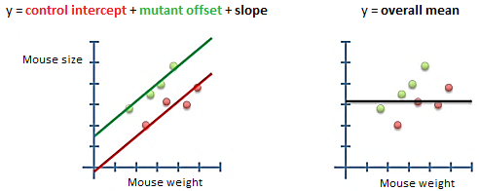
Now, we calculate $F$ and the p-value …
$$F=\frac{\frac{SS\left(simple\right)-SS\left(fancy\right)}{p_{fancy}-p_{simple}}}{\frac{SS\left(fancy\right)}{n-p_{fancy}}}=21,88→p-value=0,003$$
$$p_{fancy}=3$$
$$p_{simple}=1$$
The small p-value says that taking weight and mouse type into account is significantly better at predicting size than just using average size.
EXAMPLE 2
If we do a super simple linear regression, we would have a model that takes weight into account but ignores the fact that some mice are normal and others are mutants.
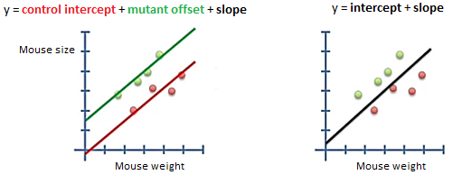
Now, we calculate $F$ and the p-value …
$$F=\frac{\frac{SS\left(simple\right)-SS\left(fancy\right)}{p_{fancy}-p_{simple}}}{\frac{SS\left(fancy\right)}{n-p_{fancy}}}=32,6→p-value=0,0023$$
$$p_{fancy}=3$$
$$p_{simple}=2$$
This small p-value suggests that using both weight and mouse type is better at predicting mouse size than weight alone.
EXAMPLE 3
Here is another simple model: it is just a normal t-test. This model ignores mouse weight.
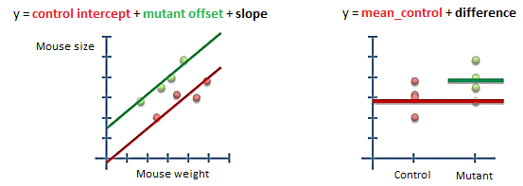
Now, we calculate $F$ and the p-value …
$$F=\frac{\frac{SS\left(simple\right)-SS\left(fancy\right)}{p_{fancy}-p_{simple}}}{\frac{SS\left(fancy\right)}{n-p_{fancy}}}=31,06→p-value=0,0025$$
$$p_{fancy}=3$$
$$p_{simple}=2$$
This small p-value suggests that using both weight and mouse type is better at predicting mouse size than mouse type alone.
So, you can see that the question you want to ask determines what type of simple model you want to use to compare your fancy model to.
BATCH EFFECT
Okey, one las example of a design matrix …
Lab A does an experiment … then lab B replicates it … however, their measurements tended to be smaller over all … this is a ´batch effect´.
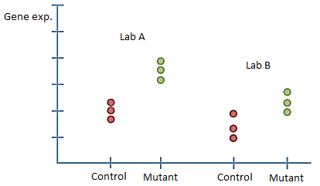
We would like to combine these two datasets to see if mutants are different from controls, but we need to compensate for the batch effect. Here is how to do it …
- First, add a term for the mean control value from lab A
- Second, add a term for the las B offset. This takes care of the batch effect
- Third, add a term for the differences between the mutant and control measurements
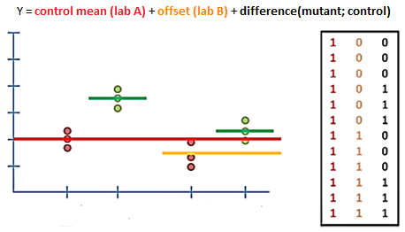
Essentially, we want to know if the last term in the equation is important or not. Alternatively, is the last column of the design matrix important ?
So, we compare the fit of this fancy equation to a simple one (that ignores the control/mutant difference) …
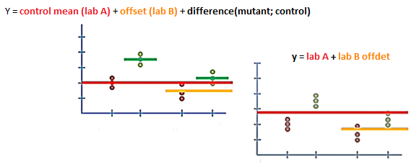
A small p-value will tell us that the equation that keeps track of the mutant/control difference predicts the gene expression better than one that does not. This will mean that the difference between controls and mutants is significant.

